1. Home screen after successful installation  
   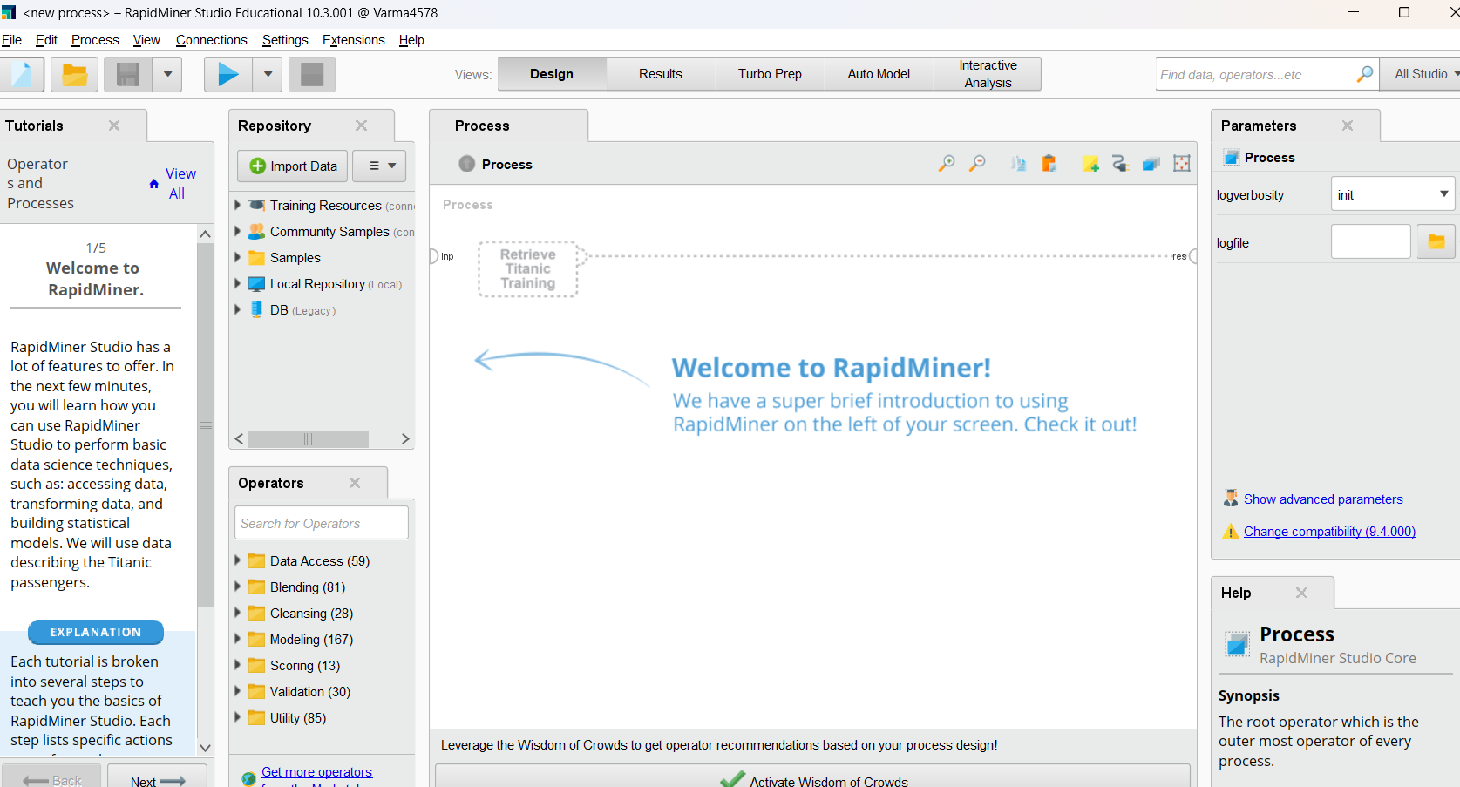
2. Downloaded and installing mongodb

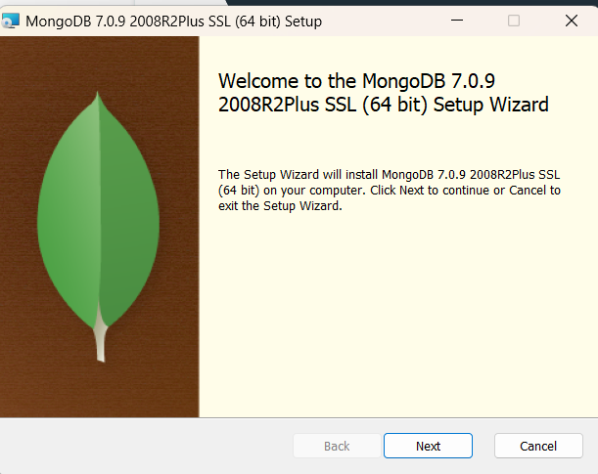

1. Installation sucessfull 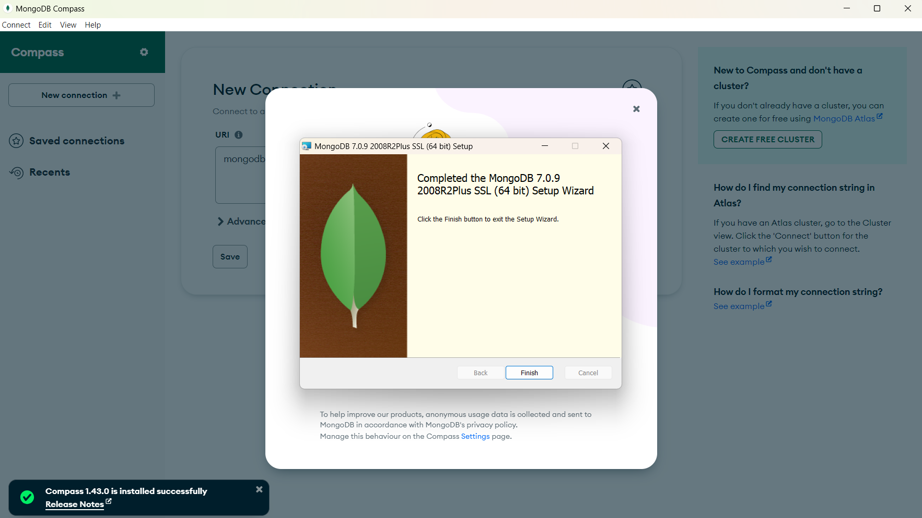
2. Created database with name airtraffic 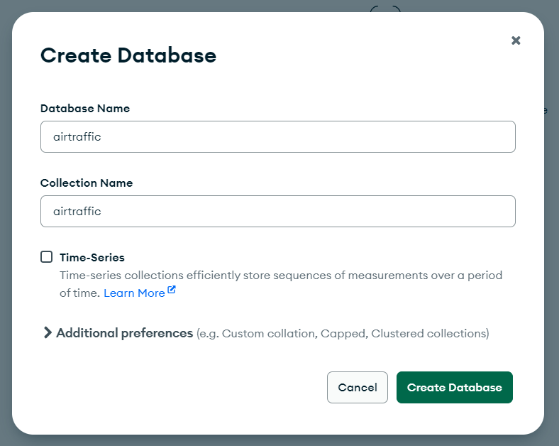
3. Imported a casv file by downloading airtraffic (csv file) from kaggle 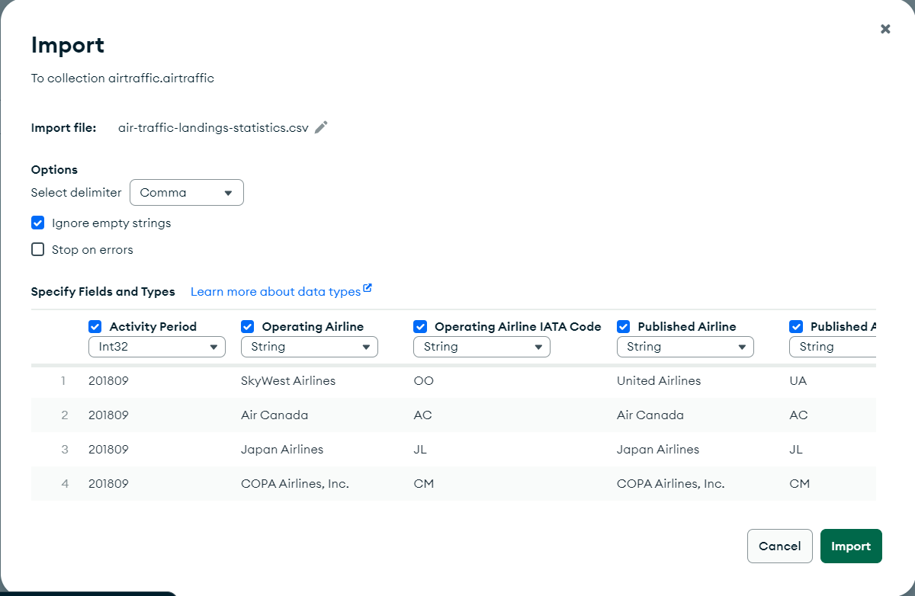
4. Tabular form of data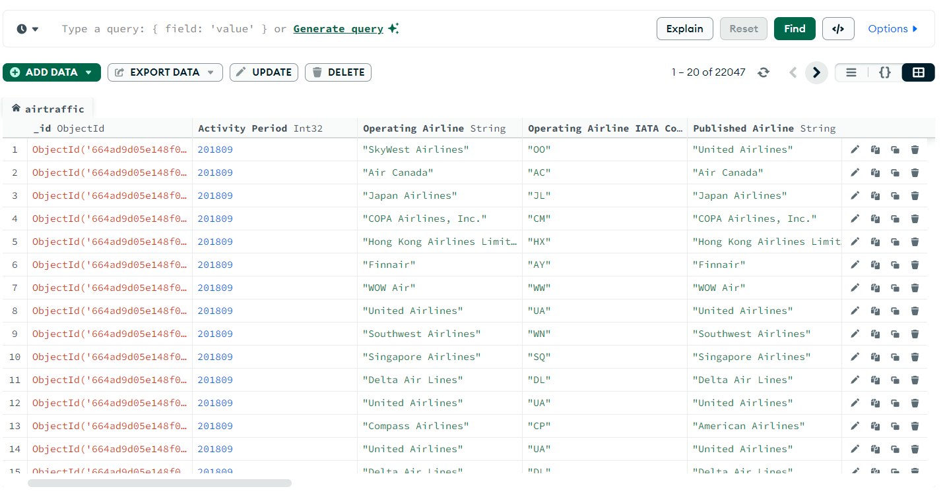
5. Schema of imported data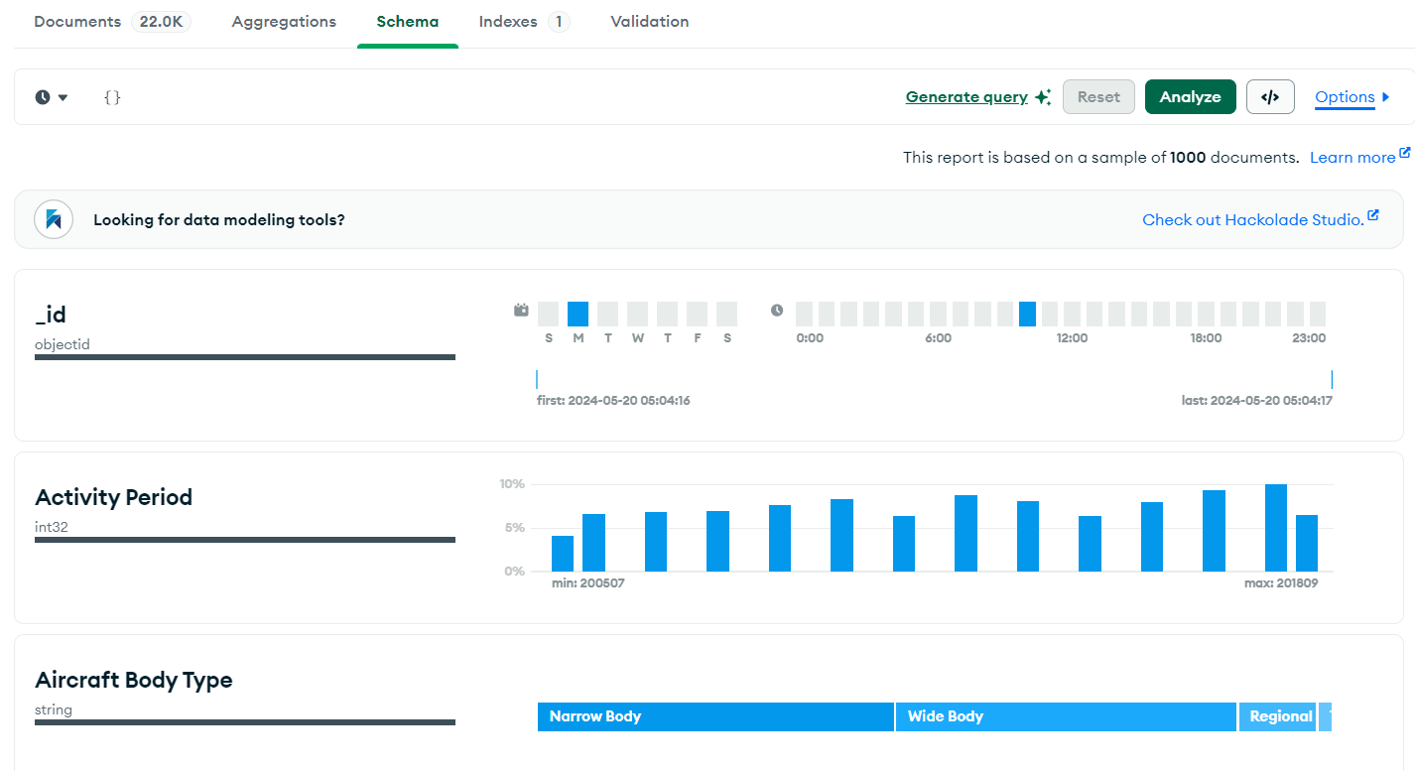
6. I wrote a query to search for the flight with aircraft model A320 and it returend me 1919 rows as shown below